LINEAR PERSPECTIVE (One Point)
One point perspective is where things look like they get smaller as they get further away. All lines come together at a vanishing point on the horizon line.
https://www.youtube.com/watch?v=Fa97I6_FwFs
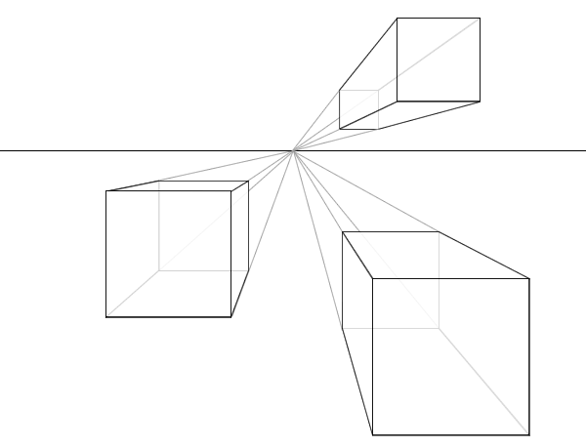
Orthogonal

Horizon line

Vanishing Point (VP)

Look at the artwork below or select your own and mark in the VP, horizon line and converging lines (orthagonals).
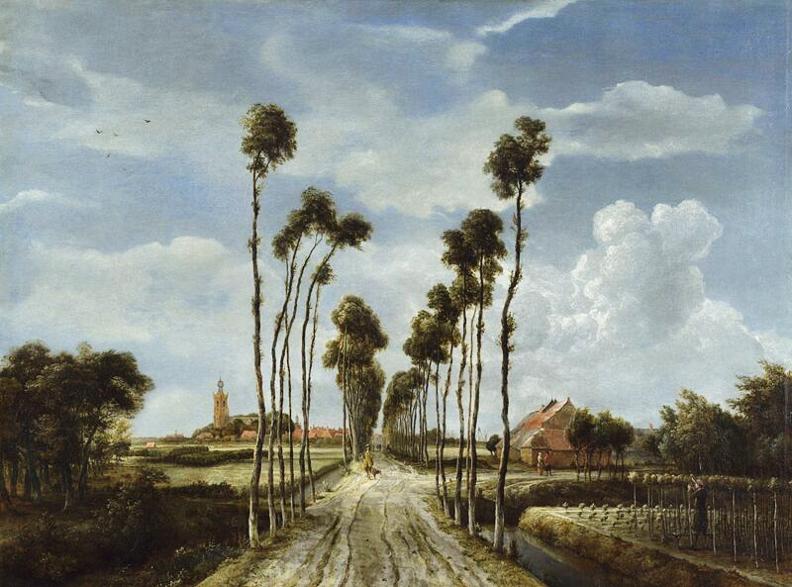  The Avenue at Middelharnis  Meindert Hobbema  1689  Oil on Canvas | 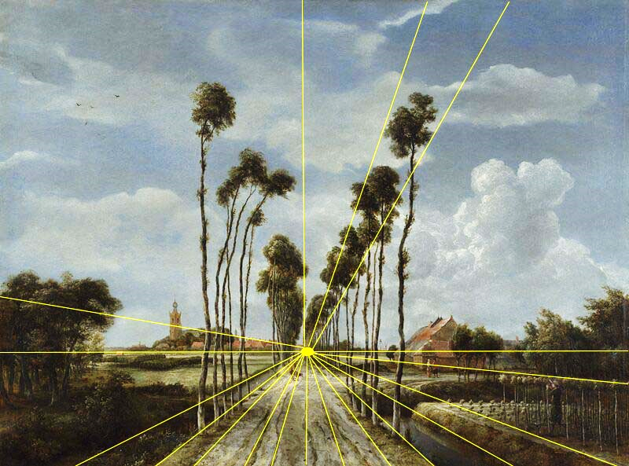  - Vanishing point directly in the centre of the path  - low horizon line  - trees become smaller in the background  - height of the trees emphasises the vastness of the sky

Objects that are closer to the viewer appear to be larger, where objects that are further away appear to be smaller.

Use the worksheet below to explore one-point perspective.
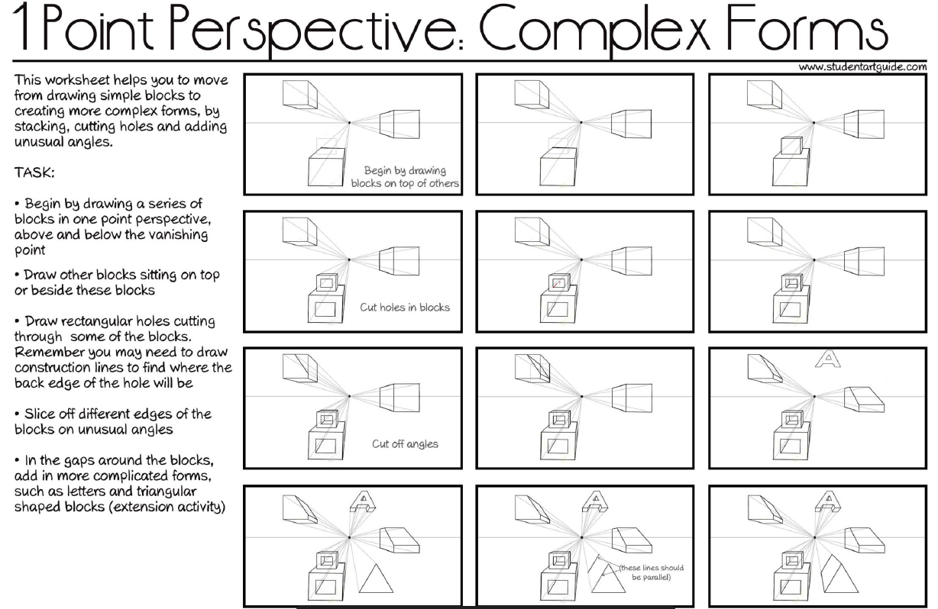
Draw a landscape scene or room using one point perspective.
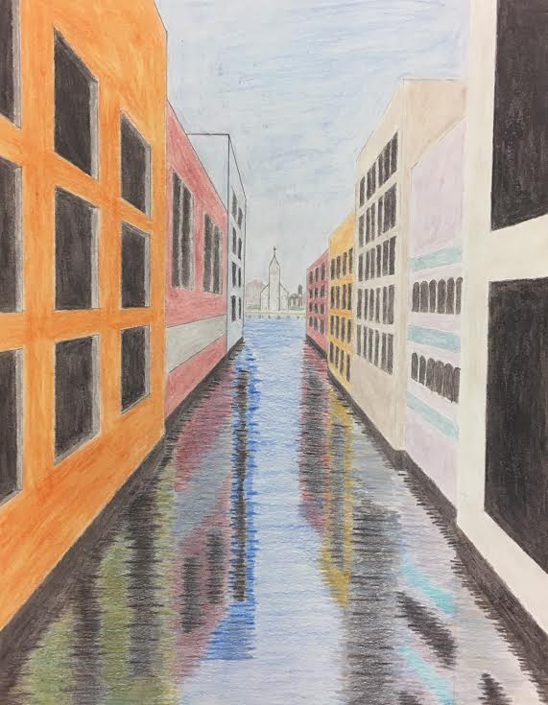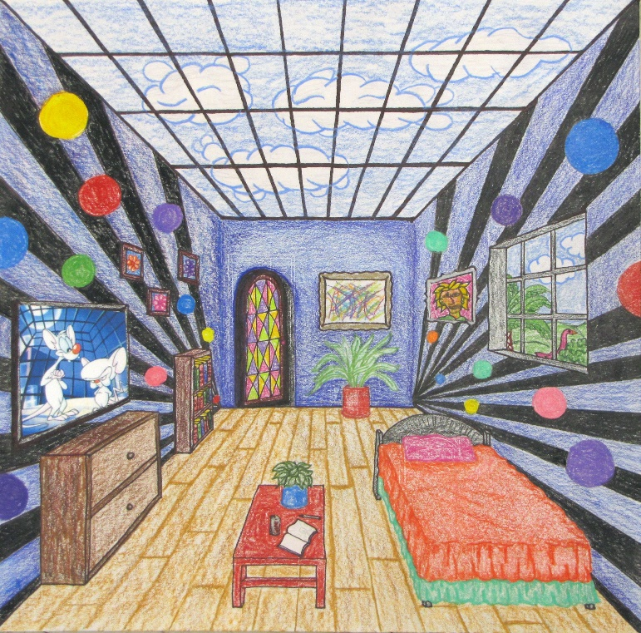
http://www.wheelerarts.org/perspective.html

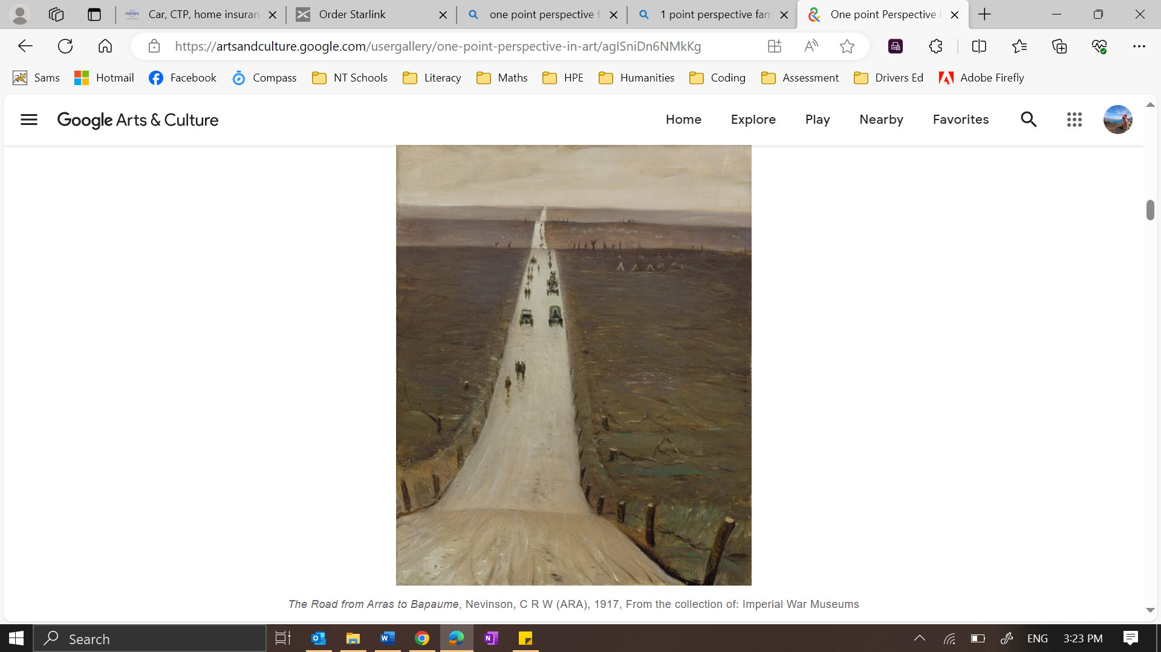

I think…

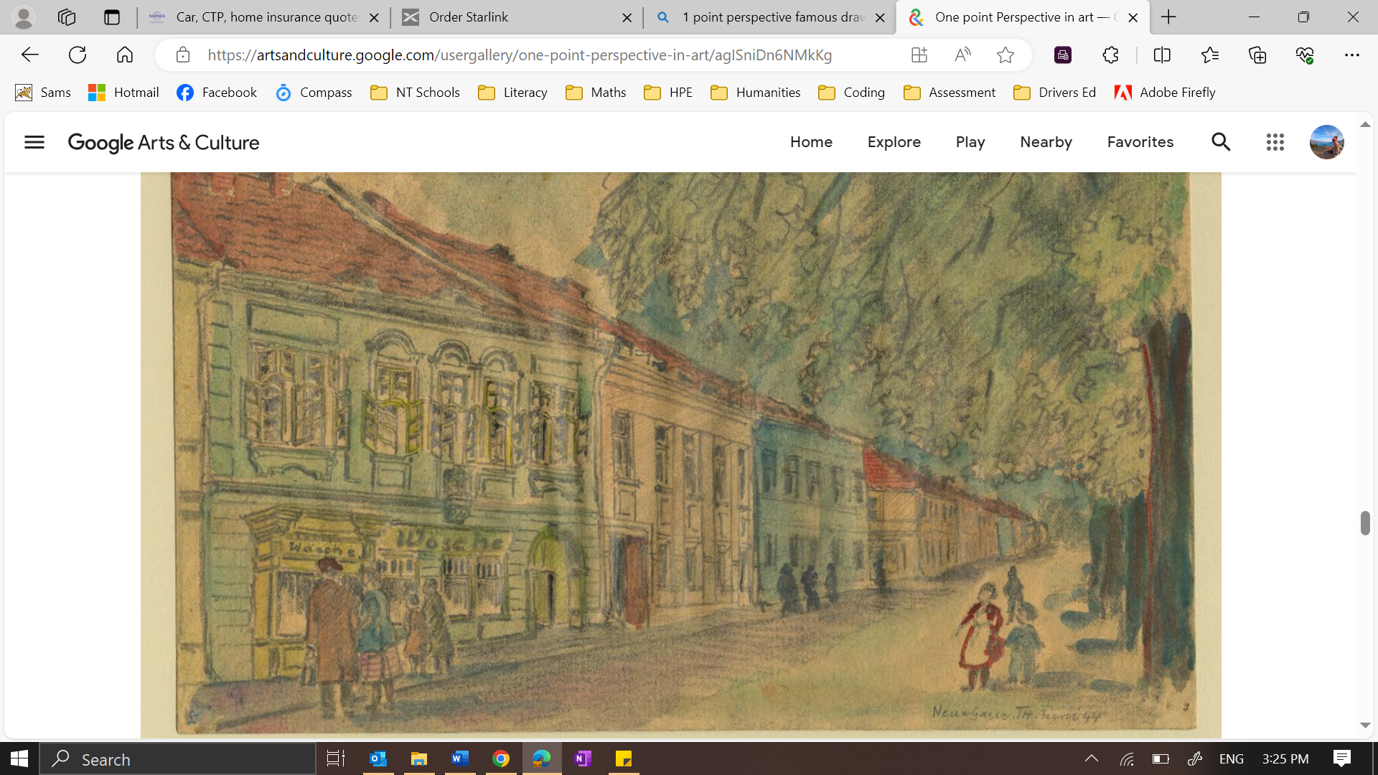
New Lane, Theresienstadt, Fabian, Fritz, 1944

I think…

New Lane, Theresienstadt, Fabian, Fritz, 1944

ONE POINT PERSPECTIVE
VANISHING POINT

HORIZON LINE

