CODES FOR SIGN LANGUAGE / PHYSICALITIES
Picture | Name | Explanation | Code | Dimension
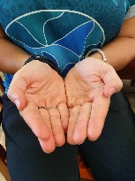 | Book | - Read the book  - Close your book  - Open your book  - Are we reading? | B | 4.2
 | Thumbs Up | Encouragement  Affirmation  Correct  Is this correct? | TU | 1.2
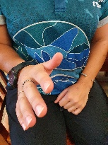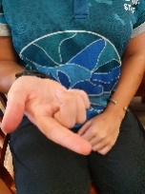 | Hands sweep with head movement | Questioning  Asking  Don’t know | HS+ | 4.2 / 1.4
 | Tongue click | Affirmation  I understand | TC | 4.2
 | Nod | Affirmation  I understand | N | 4.2
 | Shake Head (occasionally with eye contact) | No  Stop, you know what you’re doing is wrong | SH | 4.2 / 3.2
 | Lips Pursed and head lift | - I don’t care  - Yeah I get it  - Whatever  - Over there (directional) | LP | 4.2 / 1.4
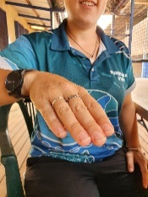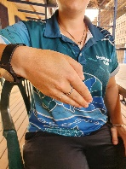 | Hand scoop palm down | Come here | HSP | 4.2 / 1.4
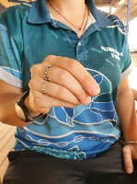 | Pencil | - Grab your pencil  - Write this down  - Are we writing? | P | 3.4 / 4.2
 | Hand flick | Go away  Leave it now | HF | 4.2 / 1.4
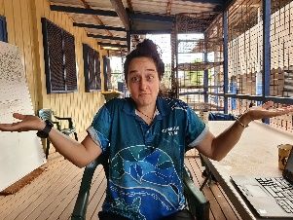 | Hands out shrug | I don’t know | HO | 4.2
 | Anga (home) | - Did they go home?  - I am going home. | A | 1.4 / 4.2
 | Point | - Gesture at something  - Direct a student | P | 4.2
 | Raise Eyebrows | Question  Confusion | RE | 4.2

